L.O – To use a protractor to measure angles

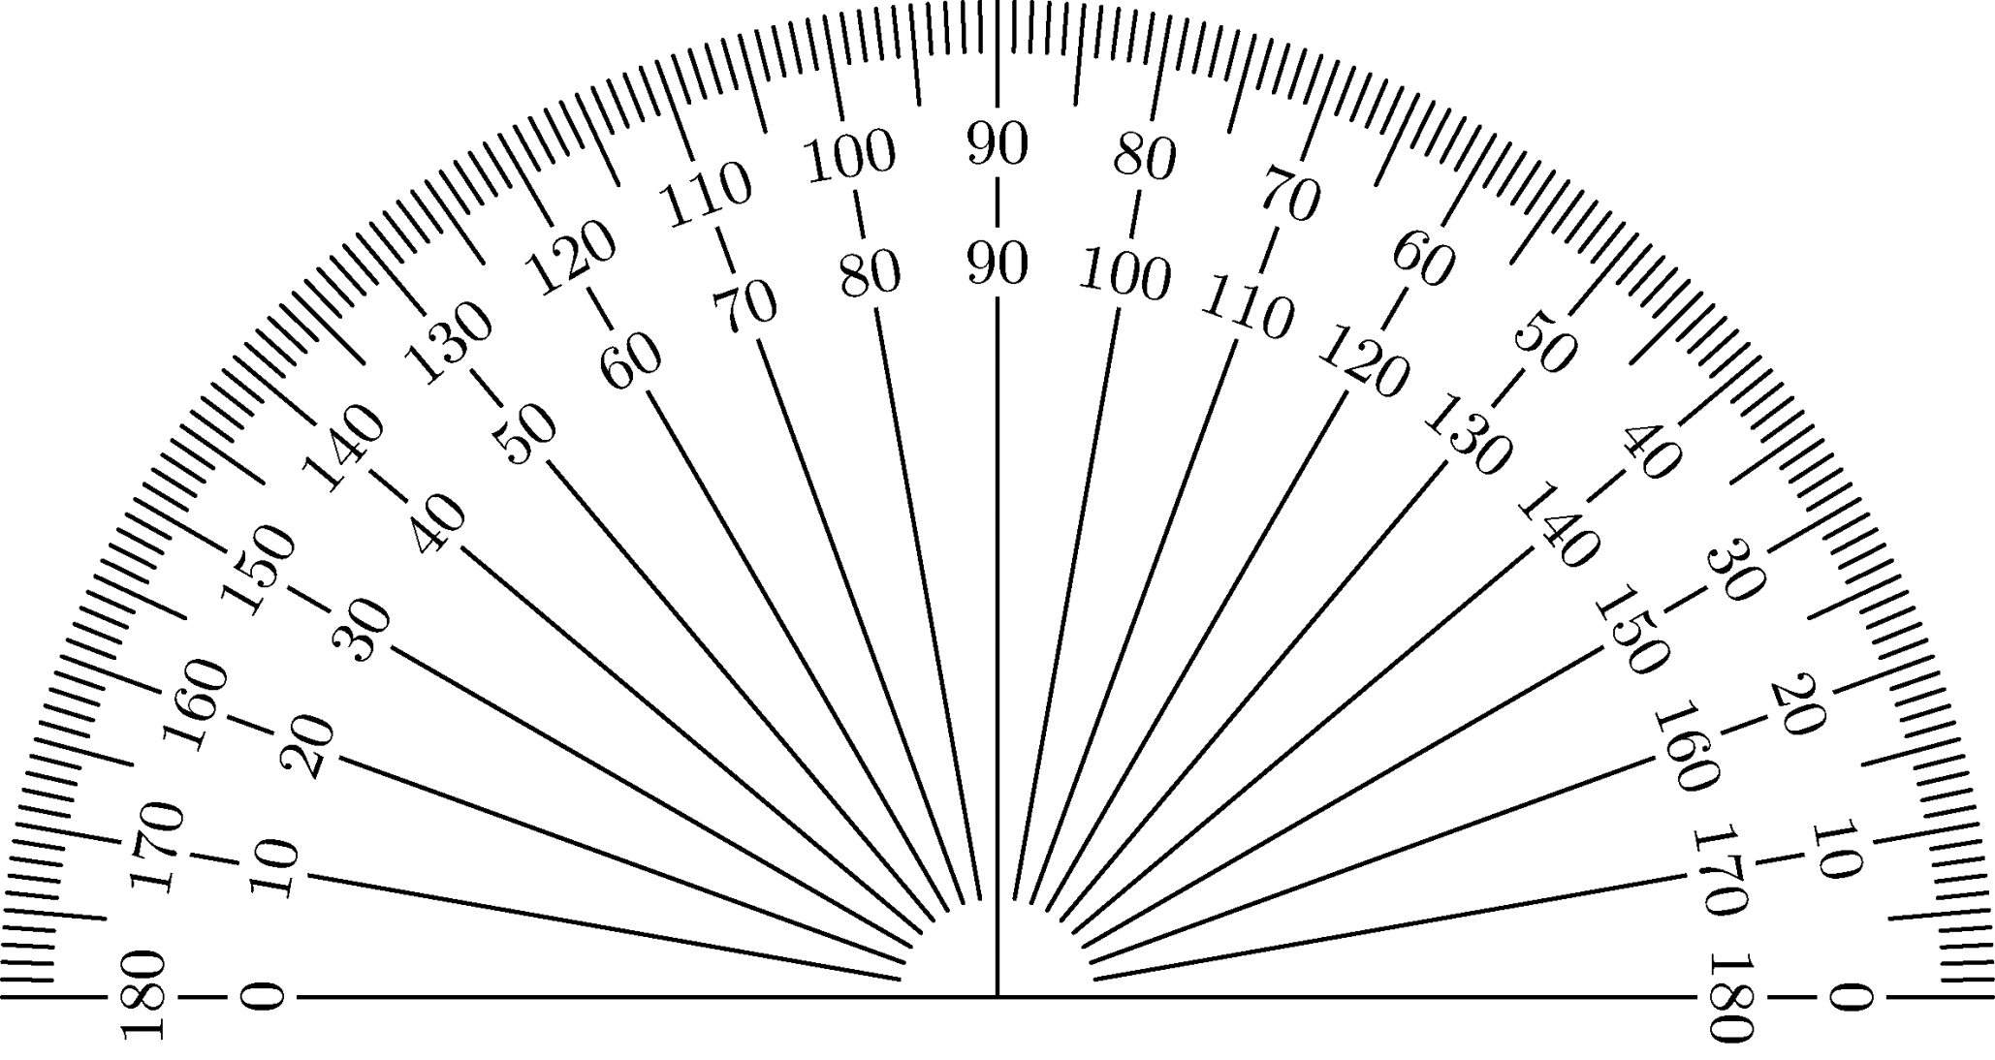

The cross is here.

Tip: Make sure you line up the cross of the protractor with the corner of the angle.

Challenge: Write whether each angle is an obtuse, acute or right angle (large, small, medium). Then use a protractor to measure each angle.

Now can you use the protractor to draw angles of the following degrees?

- 45°

- 120°

- 20°

