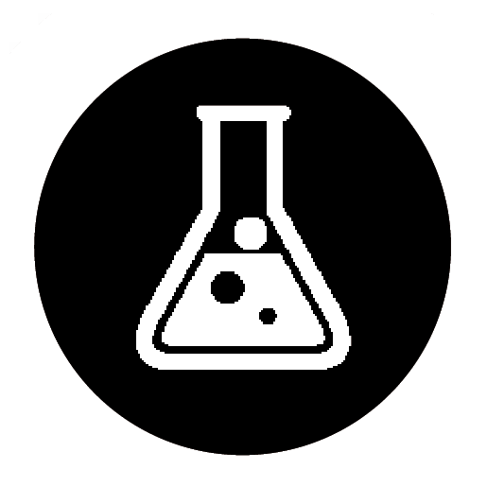 Sea water
Specification references
- C1.1.2 Mixtures
- WS 2.4, 2.7
Aims
In this activity, you will develop your confidence in using filtration and distillation techniques by purifying a sample of sea water.
Learning outcomes
After completing this practical, you should be able to
- describe what a mixture is
- separate the components in a mixture using filtration and crystallisation.
Safety
- Take care not to get burnt/scalded by hot equipment.
Equipment
- filter paper
- filter funnel
- stirring rod
- 100 cm³ beaker
- 250 cm³ flask
- evaporating basin
- Bunsen burner
- heat-proof mat
- distillation equipment
Task
Follow the instructions below to produce a sample of pure water.
- Fold the filter paper and place it into the filter funnel. Use a drop of the sea water to hold the filter paper in place if needed.
- Carefully pour the sea water through the filter paper, taking care to ensure the level of the water does not go above the level of the filter paper.
- Carefully collect the filtrate, a mix of salt and water, in a flask.
- Carefully heat the filtrate solution so that it boils and collect the pure water by distillation.
Questions
- During filtering, why is it important that the level of the sea water does not go above the level of the filter paper?

- Why does the filtrate contain salt as well as water?

- During distillation at what temperature should the distillate be collected? Explain your answer.

Student follow up
- A student has a sample of the mineral rock salt. Rock salt contains sodium chloride or ‘salt’, sand, and grit (small pebbles). Describe how the student could get a sample of pure sodium chloride from the rock salt.

(8)

