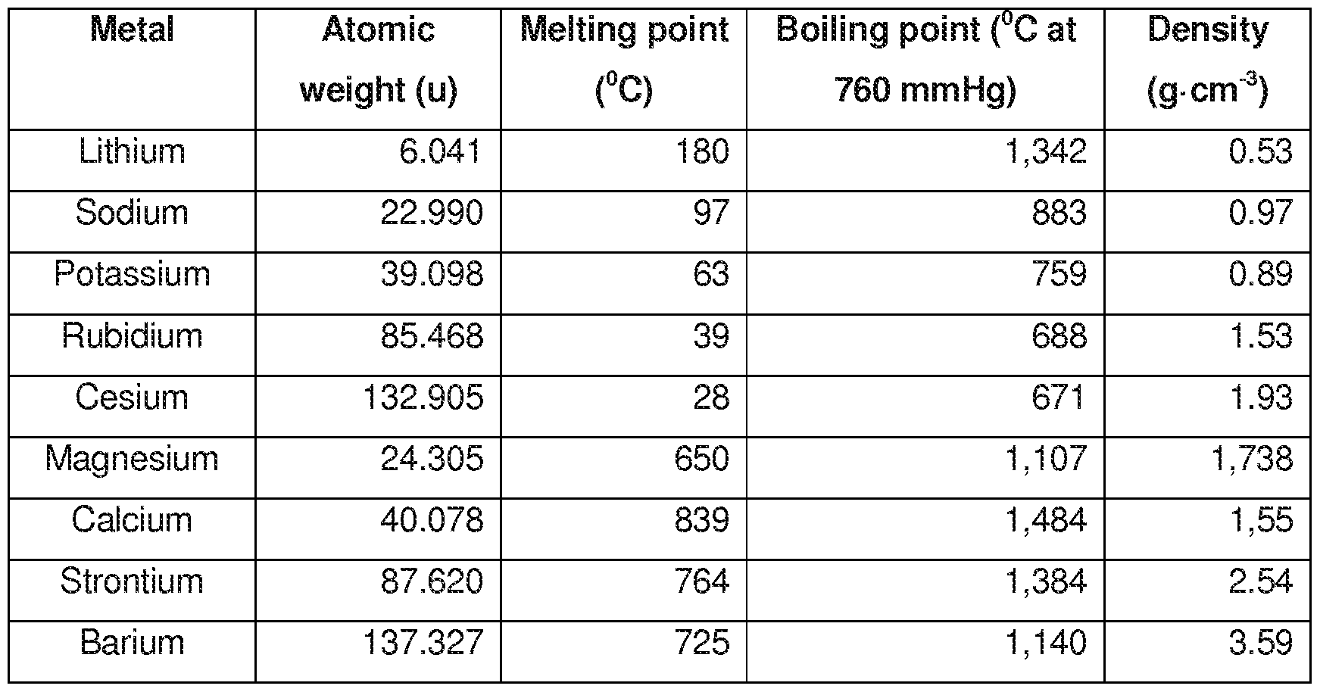

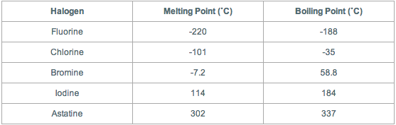

Draw a graph to show the melting or boiling points of group 7 and group 1 elements.
Why do you think the melting and boiling points are so different? What could be causing it?

