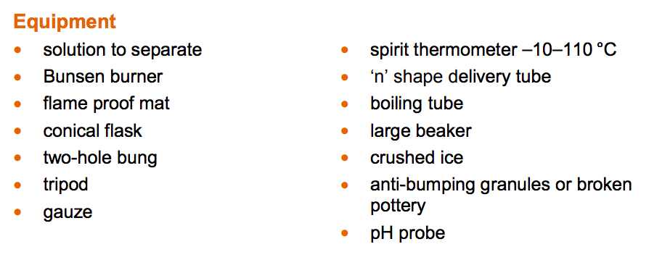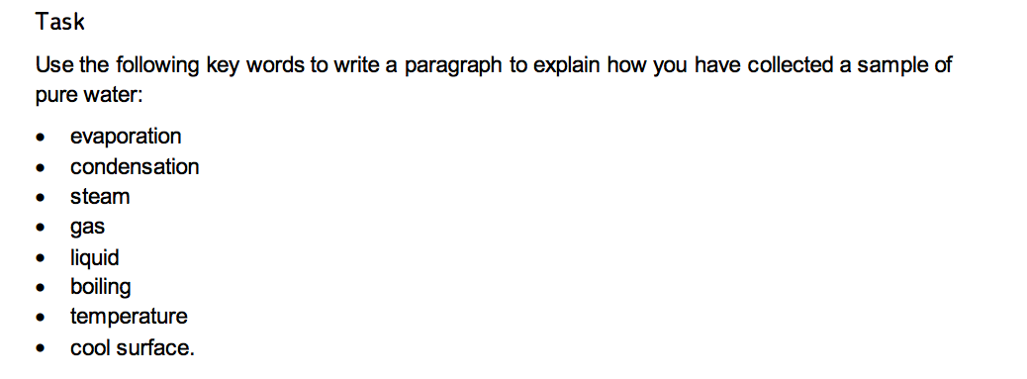

GERMAN TRANSLATIONS



GERMAN TRANSLATIONS