Temperature and thermometers
If you put your hand in hot water for 2 minutes and then in water at room temperature, the water feels _________.
If you put your hand in very cold water for 2 minutes and then in water at room temperature, the water feels _________.
The reason for this is that your skin tells you only ______________________ _________________________________________________________________________________________________________________________________
Why do people often test the temperature of water with their elbows?
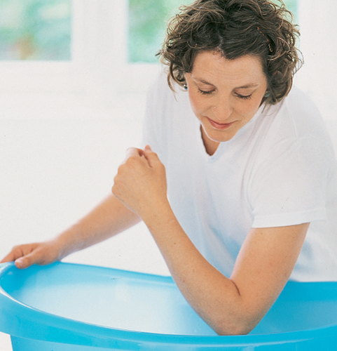
_Because____________________________________________________________________________________________________________________________________________________________________________

What’s warmer the metal or the wood?
On your desk you have a wooden pencil and a metal pen.
Which feels warmer? _________________________
Why does it feel warmer? __________________________________________________________________________________________________________________________________________________________________________________________________
Thermometers
You cannot tell how warm something is by touching it. If you want to know how warm something is, you need to use a thermometer.

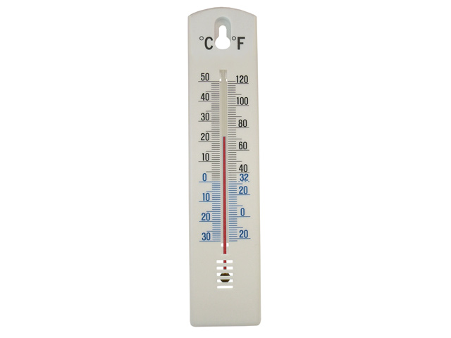
There are lots of different kinds of thermometers. Label these.
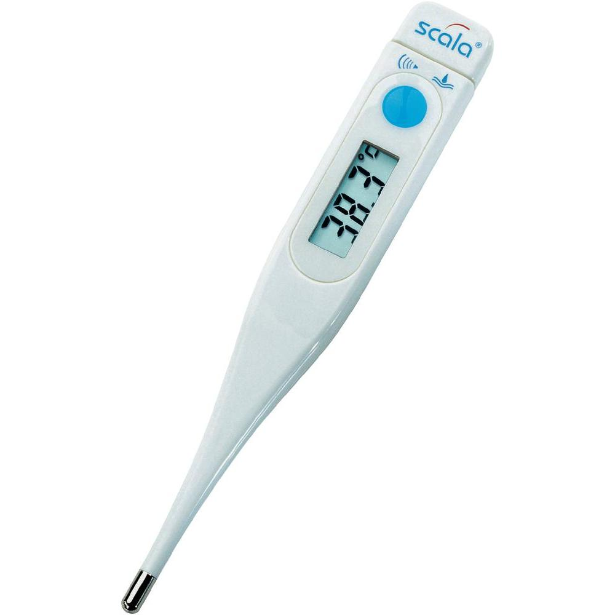

1. _____________________________________
__________________________________________

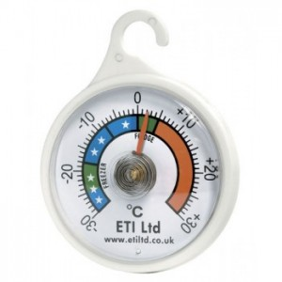

3. ____________________
_______________________
_______________________

2. _____________________________
_______________________________

The liquid (mercury or alcohol) themometer
Label the parts of the thermometer.

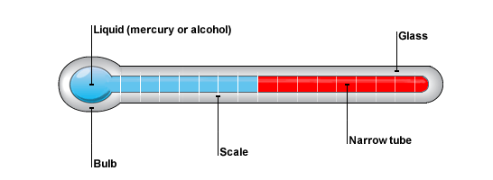

How to use a liquid thermometer
- Make sure that the bulb is completely in the thing (usually air or liquid) which you want to measure.
- Weight until the liquid stops moving up or down.
- Look horizontally at the scale.

k horizontally at the scale.
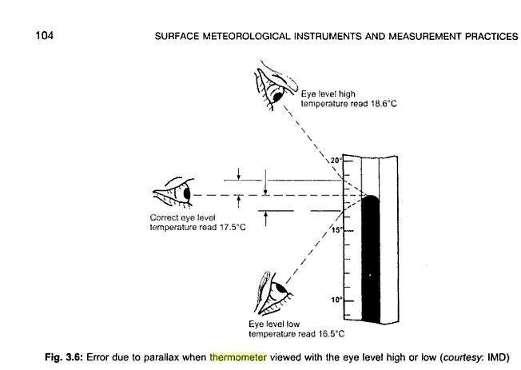
Measure the temperature
Use a liquid thermometer to measure the temperature of:
the air in the classroom __________
the air outside the classroom ___________
the temperature inside your clenched hand ____________
cold water running from the tap _________________

Different scales
Fahrenheit
This is still used in the USA and sometime in Great Britain. It was invented by a German scientist: Gabriel Fahrenheit. In this scale water freezes at 32 ºF and boils at 212 ºF.
Celsius or Centrigrade
Centrigrade (also called Celsius) is usually used in Europe and in science. It was invented by a Swedish scientist: Anders Celsius. It is also called Centrigrade because there are 100 (cent in French) degrees between the temperature water freezes (at 0 ºC) and the temperature water boils at (100 ºC.)
Kelvin
The English scientist Lord Kelvin invented this scale. This scale has no negative numbers. Water freezes at 273 K and boils at 373 K. The coldest temperature known anywhere is 0,4K – the temperature of outer space.

Now answer the questions:
Water freezes at _______ ºC, _________ºF and _________K
Water boils at _______ ºC, _________ºF and _________K
Where is the Fahrenheit scale used? _________________
Where is the Centigrade scale used? _________________
Who uses the Kelvin scale? ________________

