Making molecules
Use the Molymod kits to build the following molecules. After each one, show me!
- Water
- Carbon dioxide
- Sulphur dioxide
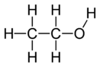
- Ethanol

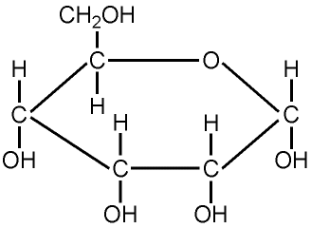

- Glucose

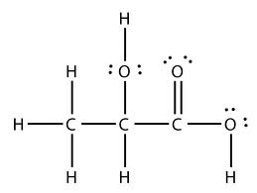

- Lactic acid

