Mixtures and solutions
We all need clean water to drink and to wash.
But water isn’t always clean.
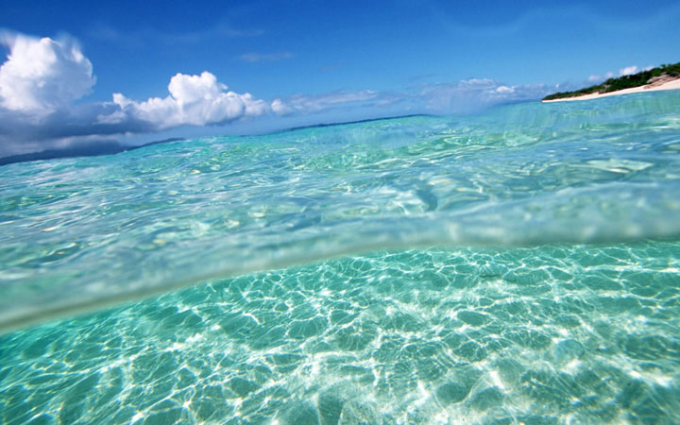
salt water
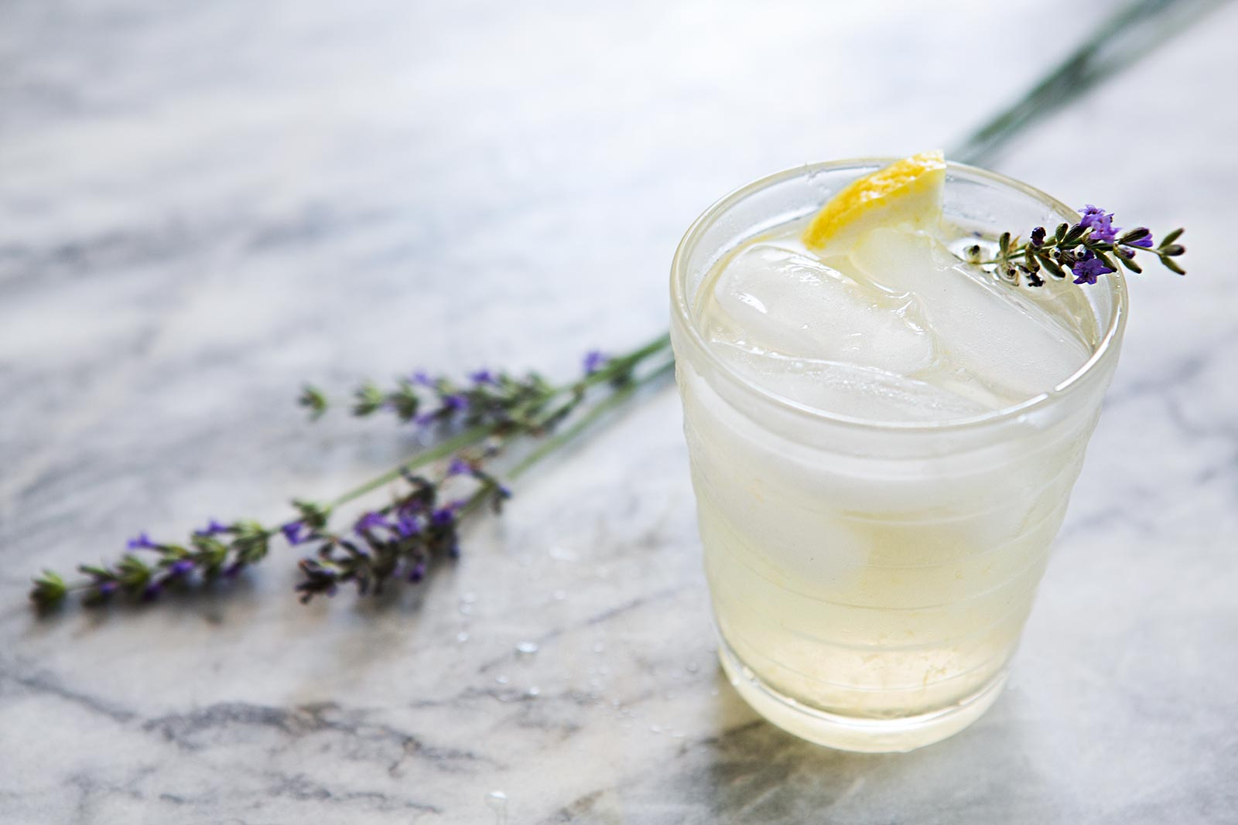
sugar in lemonade

Some things like salt or sugar can be dissolved in it.
Other things like sand are insoluble and they float in the water.
Fizzy water has gas in it.
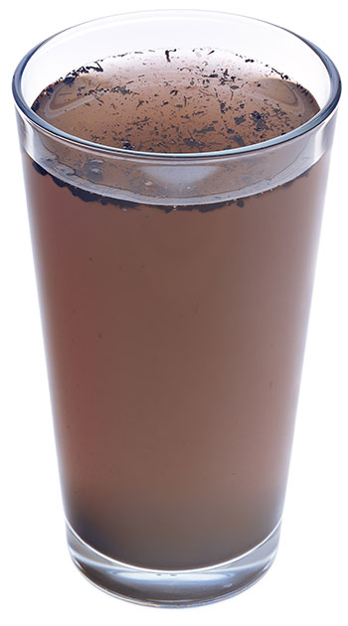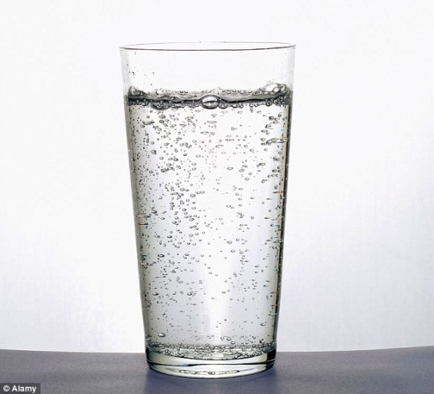
dirty water fizzy water

How can we get clean water?
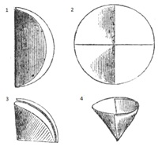
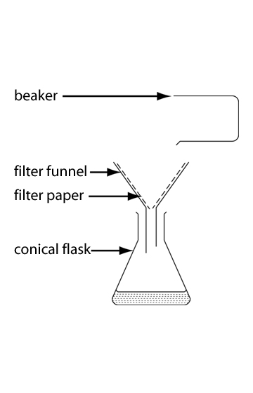

Sieve or filter
If there is something insoluble in the water, you can sieve it or filter it.
First fold the paper in half and then in quarters. Then open the paper out and put it in a funnel. Put a small amount of solution in and collect the clean water in a conical flask.

Compare the clean water and the dirty water.
How do they look?
____________________________________________________________________________________________________________________________________________________

Explain how you could test how clean the water is.
______________________________________________________________________________________________________________________________________

Extracting gas from fizzy water
How much gas do you think there is in 50 ml of fizzy water?
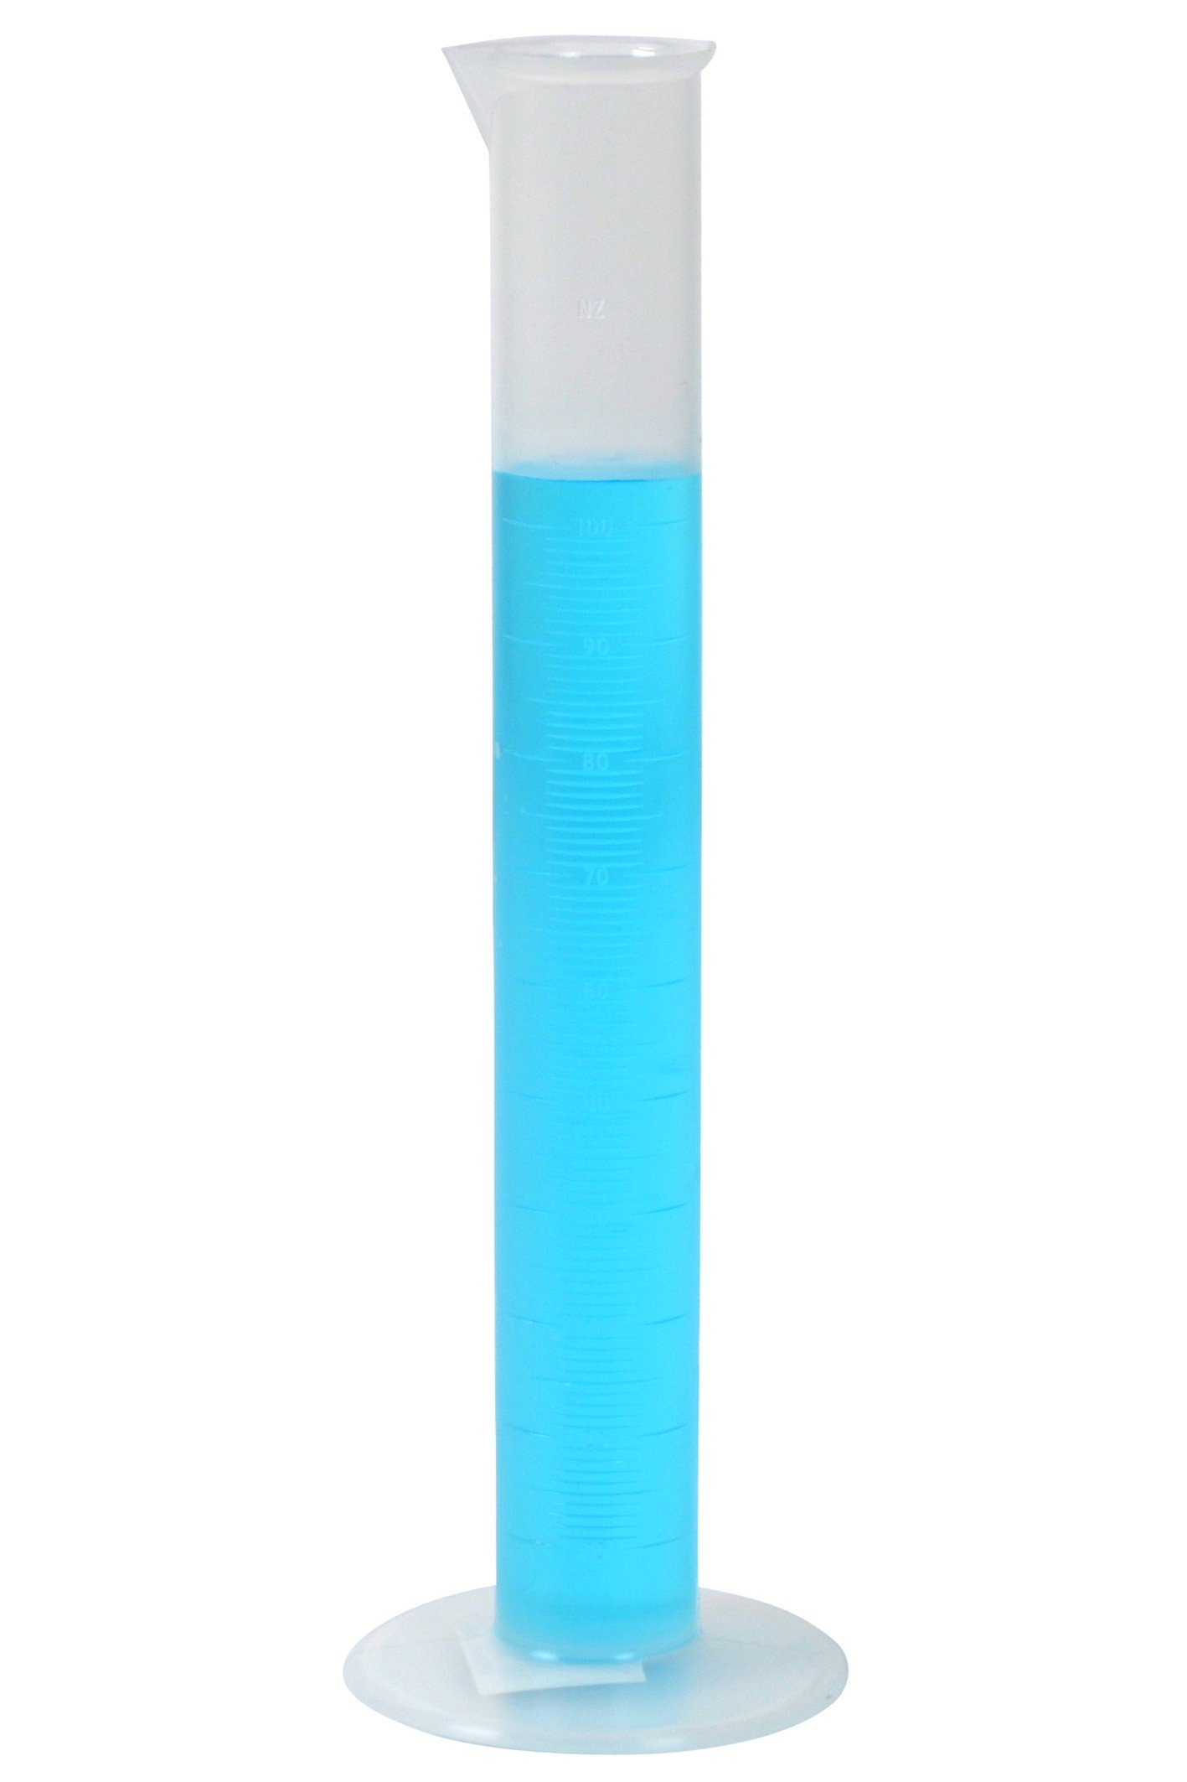
_____________

Put 50 ml of fizzy water in a measuring cylinder.
Measure it exactly.
Seal the top.
And shake.
Open the top and let the gas out.
Repeat until no more gas comes out.
How much water do you have in the measuring cylinder now?
_________________
How much gas was there in the water?
________________

Distilling sea water
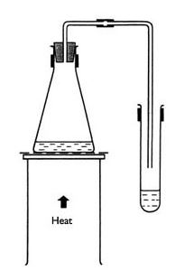
Most water on the earth is sea water.
We can’t drink salty water. How can we get pure water from sea water?
We can’t filter it because salt is soluble – it dissolves in the water.
So we distill it.
- Put about 100ml salt water in the conical flask.
- Put the bung in.
- Hang the tube into the second flask.
- Heat the salt water until it boils.
- Make notes of what happens.
Do you get water in the second flask? Why? Explain what happens.
________________________________________________________________________________________________________________________________________________________________________________________________________________________________
Explain how you could test if it is pure water.
________________________________________________________________________________________________________________________________________________________________________________________________________________________________
If you heat the water long enough, what will be left in the first flask?

