Wot makes a molecule non polar?
What mackes a molecule polar?
Why is The oxygen side of water more negative?
What are the symbuls for more positive/more negative?
Define Bond polarity.
Name and Draw the molecule shapes.
1
2
3
4
5
What ist electronegativity?
What is the diference between the electronegativities of H and O
Draw the polarity on the the Oxygen bonds of H2O ( 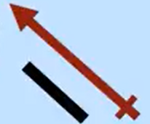 )
How doo we find the polarity of the molecule?
What is A dipole?
Draw the dipole on the warter molecule
Draw the molecular shap of SF₂
Y is CO2 linear?
Why dose BF3 have no dipole?
What does this meen?

