Calculate the volume
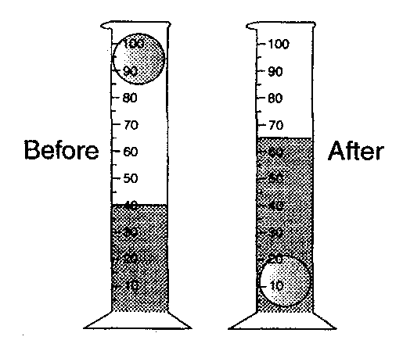
initial volume final volume
Experiment 1
We need.
- a measuring cylinder
- some objects

Method
- Put some water in a measuring cylinder and measure the volume. This is your initial volume.
- Then put the object in the water and measure the volume. This is your final volume.
- Calculate the volume of the object with the equation below
final volume – initial volume = volume of object

- Write the volume in the table below.

object | final volume (ml) | initial volume (ml) | volume of object (ml) | Volume of object cm³ | Sink or float?

Calculate the volume with an overflow vessel
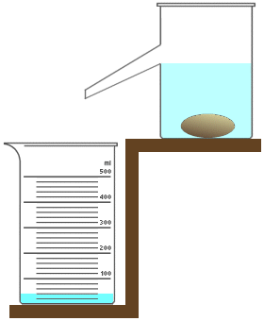
final volume
Experiment 3
We need.
- an overflow vessel
- a measuring cylinder
- some objects

Method
- Fill the overflow vessel with water until you cannot get any more water in.
- Put the measuring cylinder under the overflow tube.
- Then put the object in the water - If it doesn’t sink, push it just under the water.
- Measure the volume of water in the measure cylinder
This is the volume of your object

- Write the volume in the table below.

object | volume of object (ml) | Volume of object cm³ | Sink or float

Results of experiments

________________________________________________________________________________________________________________________________________________________________________________________________________________________________________________________________________________________________________________________________________________________________________________________________________________

