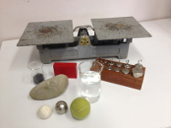
1. How can we measure the mass of an object?
Equipment
- Balance scales
- Known weights
- Different objects
- Beaker with water
- steal balls
Method – how do you use a balance scales
- Put the object on the scales
- On the other side put weights until the scales are exactly balanced.
- Add the weights together to find out the mass of the object.

Results – find the mass of five objects
- Find the mass of at least five objects with the balance scales.
Objects | Which weights did you use? | Mass

Part 2: How can we measure the mass of an object?
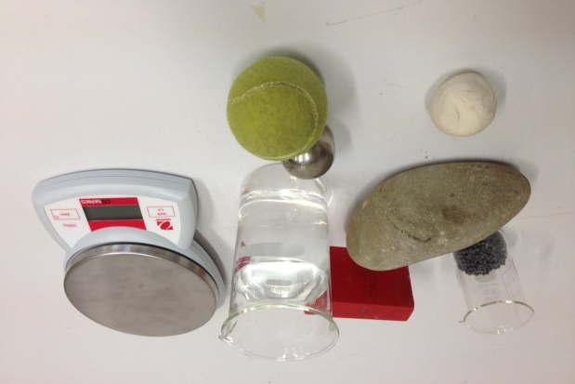
What do you need?
- Laboratory scales
- Different objects
- Beaker with water
- Small steel balls
How do you use the laboratory scales?
- Set the scales to zero
- Set the unit to grammes
- Put the object on the scales
- Read the mass from the display
How do the scales work?
In the scales there’s a spring that is pressed together by a mass. The bigger the mass, the more the spring is pressed together. In the factory they measure how much a known mass presses the spring together and then calibrate it so that you can read it on the display.
It is the force of gravity which presses the spring together. The force of gravity is different in different places. It’s less at the Equator and more at the North Pole. It’s less on the moon. This means that you need to know where you want to use this kind of scales, for it to give you the correct mass.
Your mass is the same everywhere. The force of gravity isn’t the same.
Method
- Find the mass by using the laboratory scales!
Object | Mass

- Find the mass of the water in the beaker (Only the mass of the water – not of the beaker)! Describe how you did it!

- Find the mass of a small steel ball. Describe how you did it.

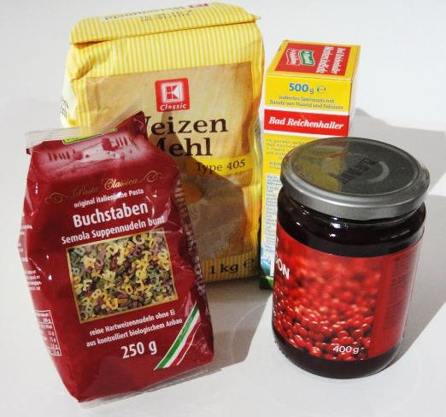
How can we find out the mass of an object?
Equipment
different objects
How can you find out the mass without scales
You can’t measure the mass of an object without scales
But it’s often written on certain objects.
Method
- What fits together? Write the correct mass next to each object
apple |  | 1500 kg
male African elephant |  | 3 g
car |  | 2 mg
sugar cube |  | 100 g
grain of salt |  | 0.15 kg
bar of chocolate |  | 5 t

- Read what mass it says on the object! Calculate it in grammes or kilogrammes!
Object | Mass, that it says on the object | Mass calculate in grammes or kilogrammes

