The (three) states of matter
They are called _________, liquids and _________.
Most substances can exist in all three states.
You can heat or cool them to make them change states.
Water can be __________ (ice) and when you heat it, it becomes _________ (water). Heat it again and it becomes a _________ (steam).

The properties of the states
solids: ____________________________________
They have a fixed shape
____________________________________
liquids: you can pour them
____________________________________
____________________________________
gases: _____________________________________
______________________________________
They don’t have the same volume

Changing states
Changing the temperature can change the state of something. Write the correct words over the big arrows.
Heating
solids liquids gases

Cooling
gases liquids solids

Heating and cooling
When you heat a substance its volume increases before it changes state.
So when you heat a liquid, it takes up more space. This is how a liquid thermometer works. When the air (or your body) gets warmer, the liquid expands and you can read on the scale how warm it is.
When it cools down ____________________________________________________________
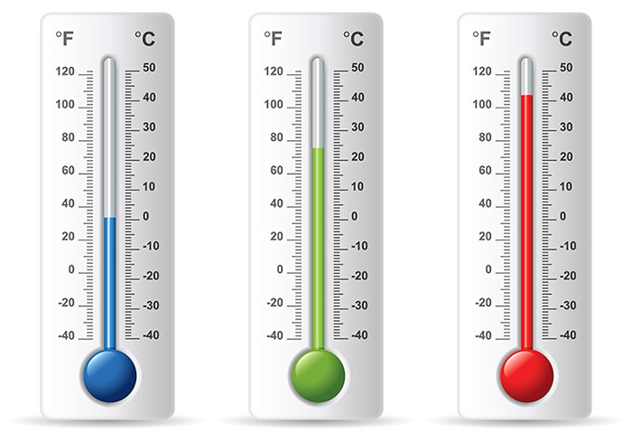
colder warmer hotter
_______________________________________________

