**Fish**

Fish – swimming like a fish

Fish have skeletons like birds and mammals. They are **vertebrates**.

They are **cold-blooded**. This means that they cannot control their temperature. They have to live in water that is the right temperature.

**Fish are adapted to life in water:**

They are **streamlined** so that they can swim more easily.

They have bony **scales** which protect them.

They are slimy. The slime (or **mucus**) protects them from disease and helps them swim more easily.

They have fins. These help the fish to move forwards and to steer. They also stabilise them in water.

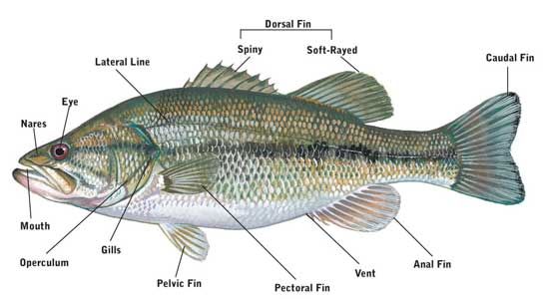

Their senses – Does a fish have ears?

They can hear and they have ears but you can't see them.

They can see. Some fish are adapted to see well in the dark.

They can smell – with their nostrils or nares.

They also have a lateral line which helps them feel movement in the water. This helps them find prey or escape from predators.

Shape

Fish have different shapes but they are all smaller at the front so they can move well in water.

|  |  |
| --- | --- |
| Some are streamlined, or fusiform, so they can swim easily in the water and fast. | Fusiform |
| Some are **laterally compressed** (flattened from side to side). These are not very streamlined so they cannot swim as fast but they are good at hiding in rocks. And they can get food other fish can't reach. They are often camouflaged to help them hide. | Laterally Compressed |
| Other fish are flattened from top to bottom.  Fish with this body shape spend most of their time at the bottom.  They are usually camouflaged or can change colour to match the bottom. | Depressed |

Fins

Fish use fins for swimming and sometimes for protection.  Some fins are paired. That means they have two fins; one on each side, like the pelvic and pectoral fins. The others are unpaired or single like the caudal fin (the tail), the dorsal (on the back), and the anal fin.  Different fish use their fins differently. Most fish use their tails to move through the water and their other fins to steer with.

**Caudal fin (or tail):**This usually helps the fish move forward. They swim with their tail.

**Pectoral Fins:**Fish usually use the pectoral fins for turning, although they can use them to touch things, taste things and to help swim with.

**Pelvic Fins:**Paired pelvic fins make the fish more stable and can slow some fish down.

**Dorsal Fin:**This can be one fin or be separated into several fins.  This is usually used to change direction and to keep the fish stable.

**Anal Fin:**The anal fin adds stability.