Breathing
Gills
Fish don't have lungs. They breathe with their gills. Oxygen enters the blood and carbon dioxide leaves the blood at the gills. The gills are at the back of the mouth and they have filaments which almost look like feathers. The gills of a healthy fish are bright red due to the oxygen in the blood that is very close to the surface of the gills. (Without oxygen, the gills would be brown.) In bony fish, the gills are covered by a bony place called an operculum.
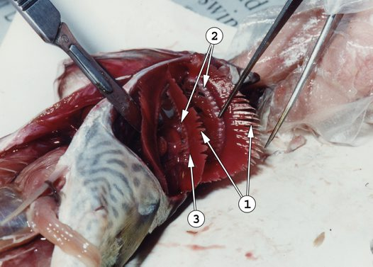
Gills of the Blue Mackerel.
1. Gill filaments - the site of gas exchange
2. Gill rakers – look like small teeth along the front edge of the gill arch
3. Gill arches - support the gills
Breathing Underwater
Fish, like most animals and plants, need oxygen to survive. The oxygen that fish "breathe" is dissolved in the water. The oxygen goes into the water from the air or from plants when they photosynthesise. Water goes in to the fish's mouth, moves across the gills and passes out of the gill slits. The skin of the filaments is very thin so oxygen can move into the blood and carbon dioxide can go into the water.
When it is hot, there is less oxygen in water. When fish live in small or shallow ponds, they can have problems in summer and in a hot summer many fish can die.

